**GLS University**

**FCAIT Embedded System Project**

**Project Title: IOT Based Unwanted Weeds Remover**

**Project Member details :**

1. C-07 Bhakhar Parth Pareshbhai

2. C-46 Mulivala Vrunda Mananbhai

3. C-75 Rojesara Aaryan Sanjaybhai

**Components:**

● Arduino uno

● Motor Driver Shield

● Camera

● Robotic Arm

● Dc Motors and Servo Motors

● Robotic Drill (For drilling land)

● Rechargeable Lithium Battery

**Project Model picture:**

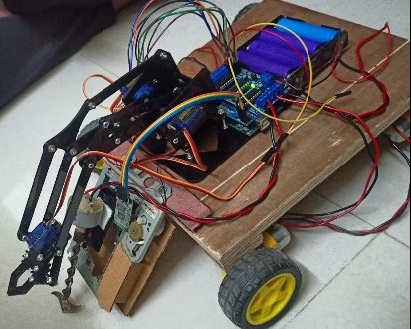

**Project Details:**

Agriculture is a backbone and most important stream of India. There are some innovations in agricultural field but not as much as other fields. So to make the work of farmers more efficient and effortless we have come up with the idea of **IOT based unwanted weeds removal car**. By this piece of technology and mechanism the man can easily do some task like remove weeds from fields and collect it into a trolly bucket. It can also remove weeds by drilling it, which has strong roots. It has features like drill to break the strong roots and robotic arm to collect weeds. So the farmers just have to sit in chair and can operate whole car by using mobile effortlessly. We are also planning to introduce are app where the farmers can save all the data about there fields and car will be automated. There will also be a constant monitoring sensors fetch the report of the soil, so the data can be used to make report for soil and improve the production.

**Application of Project:** Agriculture